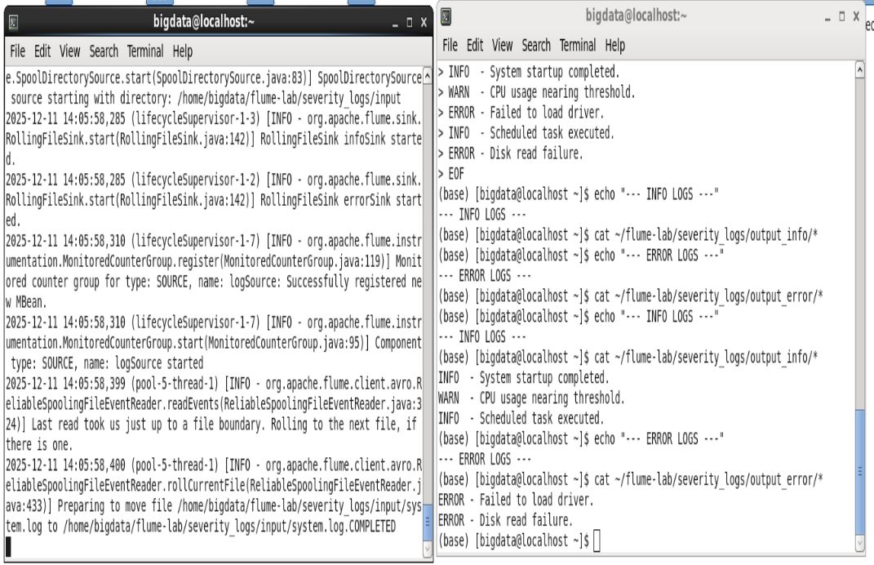

Before:
# Interceptor for INFO logs agent1.sources.logSource.interceptors.i1.type = regex_filter agent1.sources.logSource.interceptors.i1.regex = ^INFO agent1.sources.logSource.interceptors.i1.excludeEvents = false # Interceptor for ERROR logs agent1.sources.logSource.interceptors.i2.type = regex_filter agent1.sources.logSource.interceptors.i2.regex = ^ERROR agent1.sources.logSource.interceptors.i2.excludeEvents = false

After:
# Interceptor - Extract severity from beginning of line
agent1.sources.logSource.interceptors = severityInterceptor
agent1.sources.logSource.interceptors.severityInterceptor.type = regex_extractor
agent1.sources.logSource.interceptors.severityInterceptor.regex = ^(INFO|ERROR)
agent1.sources.logSource.interceptors.severityInterceptor.serializers = s1
agent1.sources.logSource.interceptors.severityInterceptor.serializers.s1.name = severity

# Channel Selector - Multiplex based on severity header
agent1.sources.logSource.selector.type = multiplexing
agent1.sources.logSource.selector.header = severity
agent1.sources.logSource.selector.mapping.INFO = infoChannel
agent1.sources.logSource.selector.mapping.ERROR = errorChannel
agent1.sources.logSource.selector.default = infoChannel

Conclusion:
Instead of two interceptors that filter
The solution was to make one interceptor that filters based on info or error and multiplex depends on this result on different channels

Full fixed code:
# Agent definition
agent1.sources = logSource
agent1.sinks = infoSink errorSink
agent1.channels = infoChannel errorChannel

# Source - SpoolDir
agent1.sources.logSource.type = spooldir
agent1.sources.logSource.spoolDir = /home/YOUR_USERNAME/flume-lab/severity_logs/input
agent1.sources.logSource.includePattern = .*\.log
agent1.sources.logSource.fileHeader = true

# Interceptor - Extract severity from beginning of line
agent1.sources.logSource.interceptors = severityInterceptor
agent1.sources.logSource.interceptors.severityInterceptor.type = regex_extractor
agent1.sources.logSource.interceptors.severityInterceptor.regex = ^(INFO|ERROR)
agent1.sources.logSource.interceptors.severityInterceptor.serializers = s1
agent1.sources.logSource.interceptors.severityInterceptor.serializers.s1.name = severity

# Channel Selector - Multiplex based on severity header
agent1.sources.logSource.selector.type = multiplexing
agent1.sources.logSource.selector.header = severity
agent1.sources.logSource.selector.mapping.INFO = infoChannel
agent1.sources.logSource.selector.mapping.ERROR = errorChannel
agent1.sources.logSource.selector.default = infoChannel

# Channels
agent1.channels.infoChannel.type = memory
agent1.channels.errorChannel.type = memory

# Sinks
agent1.sinks.infoSink.type = file_roll
agent1.sinks.infoSink.sink.directory = /home/YOUR_USERNAME/flume-lab/severity_logs/output_info

agent1.sinks.errorSink.type = file_roll
agent1.sinks.errorSink.sink.directory = /home/YOUR_USERNAME/flume-lab/severity_logs/output_error

# Bindings
agent1.sources.logSource.channels = infoChannel errorChannel
agent1.sinks.infoSink.channel = infoChannel
agent1.sinks.errorSink.channel = errorChannel

